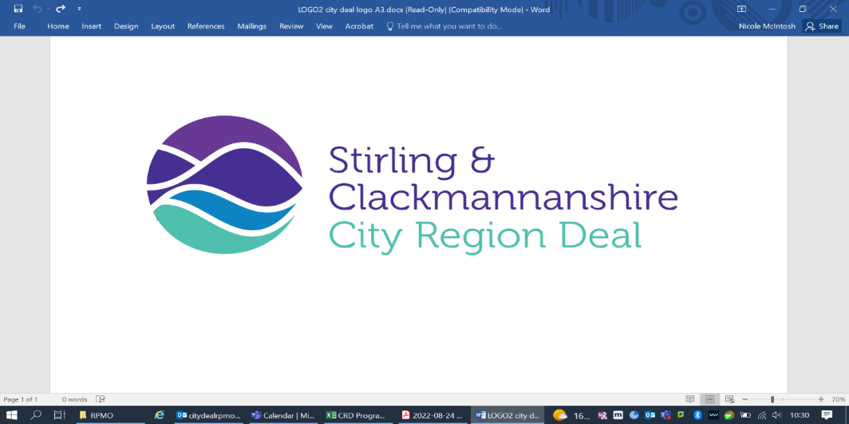

Appendix 2**: Assignment Brief**

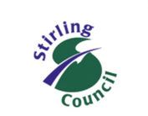

**Stirling Council Internal Audit: Assignment Brief**

**City Region Deal Review**

|  |  |  |  |
| --- | --- | --- | --- |
| **Audit Plan Reference:** | COI301/004 | **Audit Plan Year:** | 2024/25 |
| **Audit Manager:** | Gordon O’Connor, MIIA | **Lead Auditor:** | Steven McDermott, CPFA |

**Background**

The Terms of Reference of the Stirling and Clackmannanshire City Region Deal (CRD) Joint Committee (‘the Joint Committee’) require the Committee to make suitable arrangements for the review and audit of its activities. Each CRD partner is responsible for making its own arrangements for the Internal Audit of its activities and for providing assurance to their organisation’s Audit Committee (or equivalent) on their organisation’s arrangements for risk management, governance and control.

As ‘Accountable Body’, however, Stirling Council’s Internal Audit team will lead on Internal Audit work at a partnership level and report on that work, including the provision of appropriate assurance, to the Joint Committee. This is in line with the grant offer letter from the Scottish Government to Stirling Council, as Accountable Body, most recently dated 29 June 2023.

Sections 14.3 to 14.5 of the grant offer letter set out requirements in relation to Internal Audit Arrangements. It is for the Accountable Body to ensure the allocation of Internal Audit resources and to ensure that Internal Audit work is undertaken in line with the Public Sector Internal Audit Standards. The conditions are clear that the Scottish Government expects the CRD to form part of the Accountable Body’s risk based Internal Audit Plan every second year as a minimum.

The grant offer letter is clear that the focus of [Internal Audit work] will be determined by the Accountable Body’s Internal Audit Team The scope and assurance objectives for 2024/25 Internal Audit work are set out below.

**Resources**

As part of its role as Accountable Body, Stirling Council will provide the necessary Internal Audit resource for this review, in line with the conditions set out in the grant offer letter. Stirling Council’s Internal Audit Plan for 2024/25 was approved by the Council’s Audit Committee on 14 March 2024, and included resource to be allocated to review of CRD activities. Appropriate support and engagement via provision of documentation and prompt response to any queries will be required from CRD partners, which will be managed by the Lead Auditor to minimise any impact on partners’ staff and other resources.

**Timeline**

The high-level time line for the review work is anticipated to be:

* Audit review and fieldwork: December 2024 – February 2025
* Preparation of draft audit report: February – March 2025
* Report to Joint Committee: 27 March 2025 (scheduled meeting)

**Risk Context**

The scope of this review recognises and reflects the following risk and issue identified within the Regional Programme Management Office Risk Register for the City Region Deal. We will consider the existence and effectiveness of relevant controls and mitigating actions that we identify in the course of our audit work.

| **Risk / Issue** | **Risk Score** | **Owner (s)** | **Mitigating Action(s)** |
| --- | --- | --- | --- |
| R2 - If Joint Committee members are not confident to approve, then projects may be prevented from progressing. | **12** | Regional Programme Management Office /  Chief Officers’ Group | RPMO to create expert business case review group to inform and reassure Joint Committee prior to submission.  RPMO to continue with Joint Committee briefing sessions to ensure full understanding of committee agenda items. |
| I1 - Inflation is degrading the actual value of the Deal Award, causing costs to rise. The financial claims profile is moving to the right. Meaning in real terms the fund is decreasing as costs are increasing. | **20** | Chief Officers’ Group (COG) | 2024 implementation plan to consider the current financial position and future forecast and re-base activity. |

**Scope of Review**

This is a high-level review to provide assurance to the City Region Deal Joint Committee on arrangements and controls that operate at, or may impact upon, the City Region Deal at the overall partnership level. Our audit report and assurance will also be of interest and relevance to the Audit Committee of Stirling Council and to the Scrutiny and Audit Committee of Clackmannanshire Council.

We note that a separate Internal Audit Plan is in place to review arrangements at individual partner level and that those reviews have been, or will be, undertaken and reported in line with the provisions of that Plan.

**Assurance Objectives**

We will develop a plan and programme of work to allow us to provide independent assurance on specified governance, risk management and financial control arrangements for the Clackmannanshire and Stirling City Region Deal, which will include:

1. the arrangements for provision of strategic direction and decision-making through the operation of the City Region Deal Joint Committee (‘the Joint Committee’);
2. the governance framework and support arrangements in place for the Joint Committee, including the Regional Programme Management Office and relevant supporting or advisory groups;
3. the risk management arrangements that identify and manage key strategic and /or operational risks, issues and opportunities to the City Region Deal (‘the Deal’) and its various projects;
4. the arrangements and processes in place ensure that grant claims submitted to the UK and/or Scottish Governments comply with grant offer terms and conditions, and that the distribution of funding payments to partners by the Council (as the ‘Accountable Body’) is accurate, timely and efficient; and
5. the arrangements for reporting on progress of the Deal and projects to the UK and / or Scottish Governments, including Annual Implementation Plans and the Annual Report and Annual Conversation, are appropriate, timely and comprehensive.