Joint Committee 18 October 2023
Stirling and Clackmannanshire City Region Deal – Programme Status Report
Author
William Rutherford, Regional Programme Management Office (RPMO) Finance Manager
rutherfordw@stirling.gov.uk

- Deal programme highlights

- Business cases update:
  - Final iteration of the National Aquaculture Technology and Innovation Hub (NATIH) Full Business Case has been completed and was submitted to governments for endorsement on 28 August. Government endorsement was received on 3 October.
  - Government have returned feedback on the Active Travel Programme Outline Business Case. Minor amendments required in version 6 which will be resubmitted before the end of September.
  - The Strategic Outline Case for the MOD land transfer was submitted to governments for endorsement on 26 June. No feedback received to date.

- Progress overview
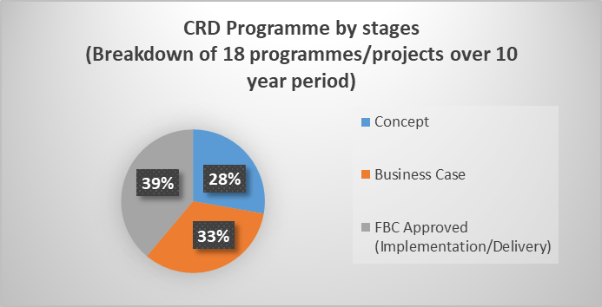
Figure 1 Programme/Project Stages
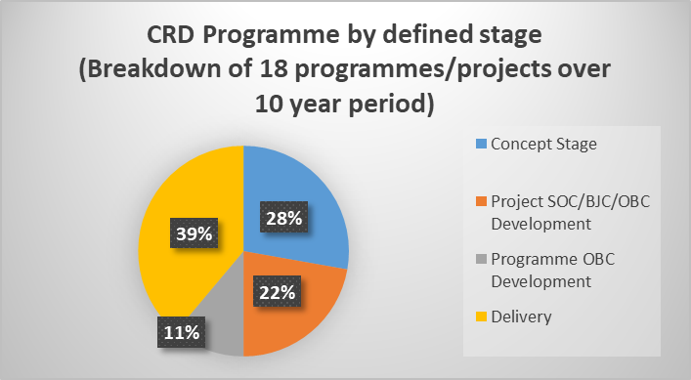
Figure 2 Programme/Project by defined stage
*variance in percentages due to statistical percentage calculations
- 72% of the programme in development.
- Five capital projects are in delivery:
- Scotland's International Environment Centre (SIEC) - Phase 1
- Walk Cycle Live Stirling (WCLS)
- Cowie – Regional Digital Hub
- Regional Energy Masterplan (REM)
- Japanese Gardens
- Two revenue projects are in delivery:
- Flexible Skills Programme
- Inclusion Workers Investment Fund (IWIF)
- Active Travel Programme in business case development.
- Four projects in business case development.
- Five projects in concept stage.

- Finance

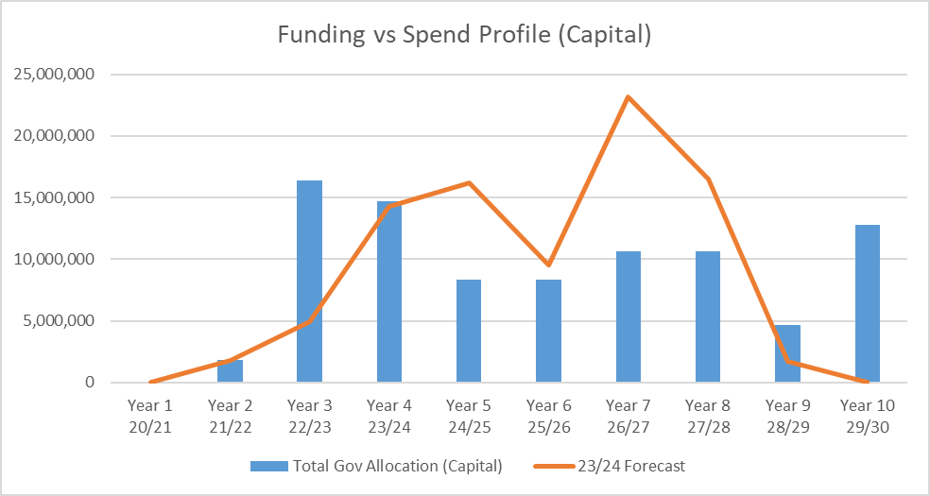
Figure 3 Capital funding vs forecast spend

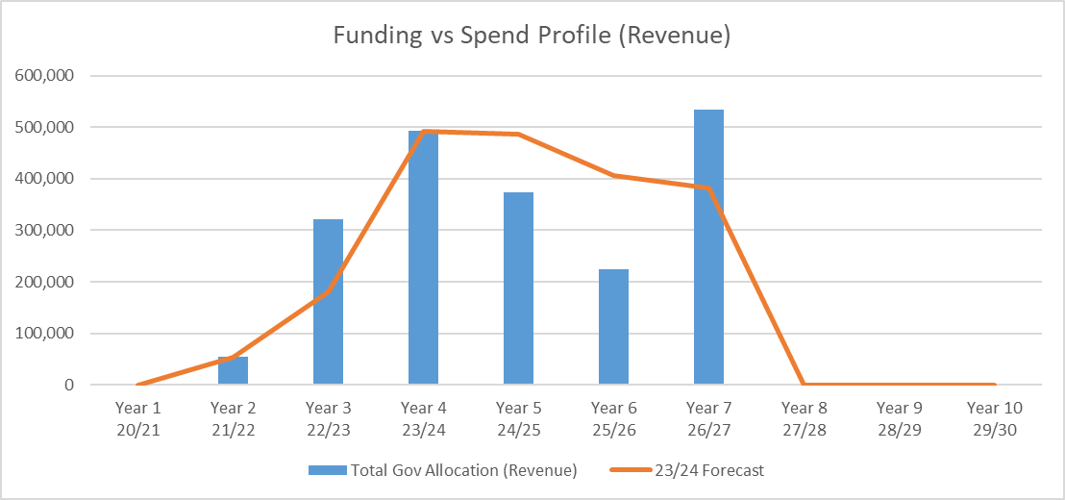
Figure 4 Revenue funding vs forecast spend

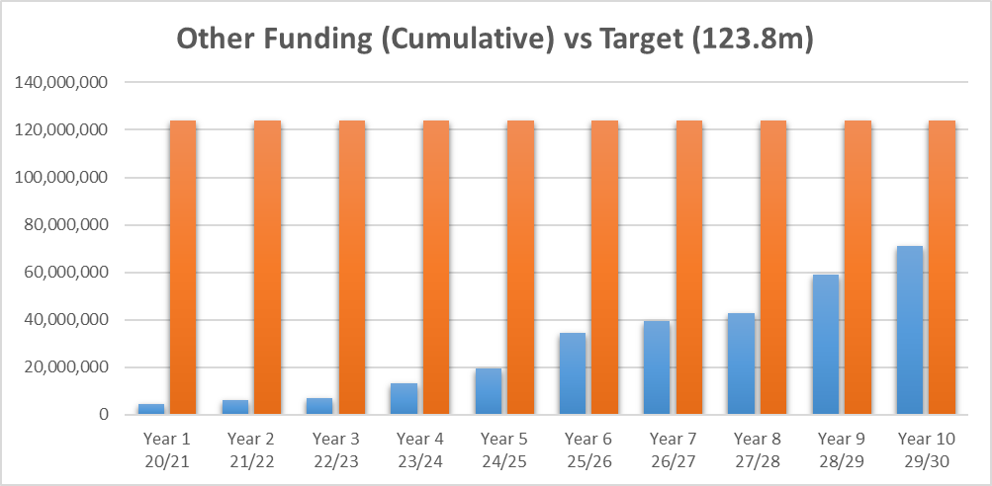
Figure 5 Investment Funding Gap

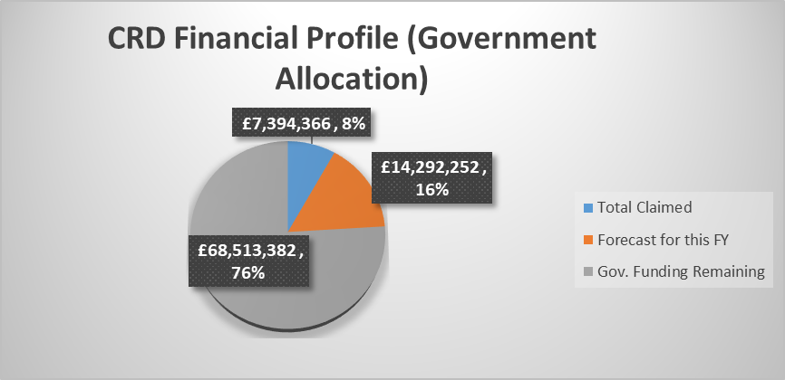
Figure 6 Full Deal Financial Allocation Vs Claims

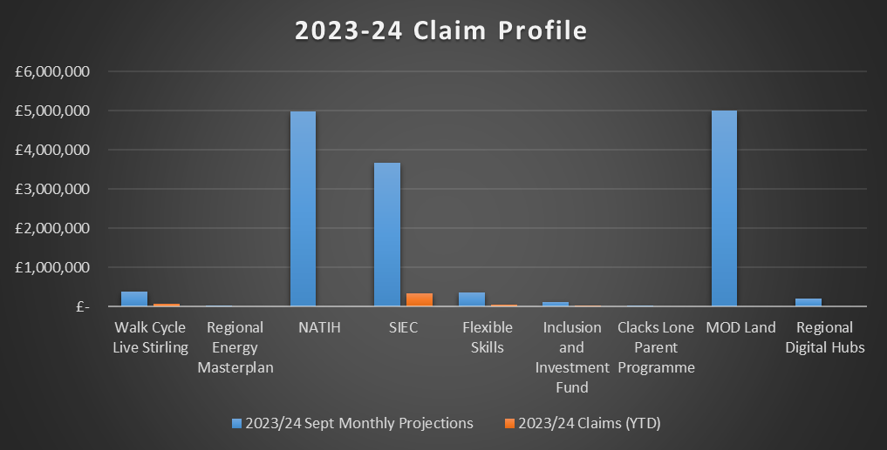
Figure 7 Financial Allocation vs claims for 2022-23

- Q1 actual claim of £0.456m - No Change
- Q2 claim forecast of £0.652m - £0.597 less in Sept Reports
- Q3 claim forecast of £3.962m - £0.295 less in Sept Reports
- Q4 claim forecast of £9.679m - £0.444m more in Sept Reports (£5m MOD included)
- Total claim forecast of £14.749m - £0.449m less in Sept Reports

- Risks

- R1 - Project cost escalation due to construction inflation and supply chain pressures impacting project viability and delivery timescales
- Action – SROs and Management Group to provide early warning of delivery risks to RPMO, and look at options for accelerating other projects alongside responding to delivery risks. COG to provide steer on proposed options.

- R2 - R1 impacting ability meet current financial profile and adding to potential cash flow pressures in future years
- Action – RPMO (following discussion and agreement at Management Group and COG) to provide governments early sight of potential impact on financial profile so as to seek support at re-adjusting this for an appropriate point.

- R3 - Other funding streams required to sustain project viability and delivery not forthcoming
- Action - SROs and Management Group to provide early warning to RPMO and COG. The partnership to work collaboratively to look at alternative funding options.

- R4 – Resource and capacity challenge across the partnership leading to project related delays
- Action - SROs and Management Group to provide early warning to RPMO and COG. The partnership to work collaboratively and agree prioritisation of projects and seek potential avenues for additional resource.

- R5 - The range and scale of Deal signed benefits are not fully realised due to a range of factors.
- Action - The partnership, supported by the RPMO and in line with governance structures, to periodically review the Benefits Realisation Plan and agree measures to be put in place to address these challenges.

- Regional Economic Advisory Group

- The group initially invested time in gaining a fuller understanding of the City Region Deal investment programme as well as other economic development opportunities in the region.
- It also reviewed the findings of the Regional Economic Strategy and developed a strategy for the coming year based on this background information.
- The original Interim Chair has resigned for health reasons and COG have implemented interim arrangements for the conduct of REAG business pending appointment of a substantive Chair.
- Under the new Interim Chair, Professor Iain Docherty, a meeting of REAG was held in September 2023. A forward plan of work has been agreed, including an analysis of financial and supply chain pressures that will inform discussions of reprofiling Deal projects, and a plan for securing the engagement of private sector representatives. These are anticipated to be available by January 2024.

- Benefits

- We are now part of a national sub-group considering approaches to benefits realisation across different regions.
- Work underway led by the University of Stirling Business School on the Monitoring and Evaluation framework.
- Some statistics around Deal benefits are as below:
  - 54 jobs across the region
  - £72,117,022 secured/targeted match funding/leverage/private investment for region (Aug 23)

