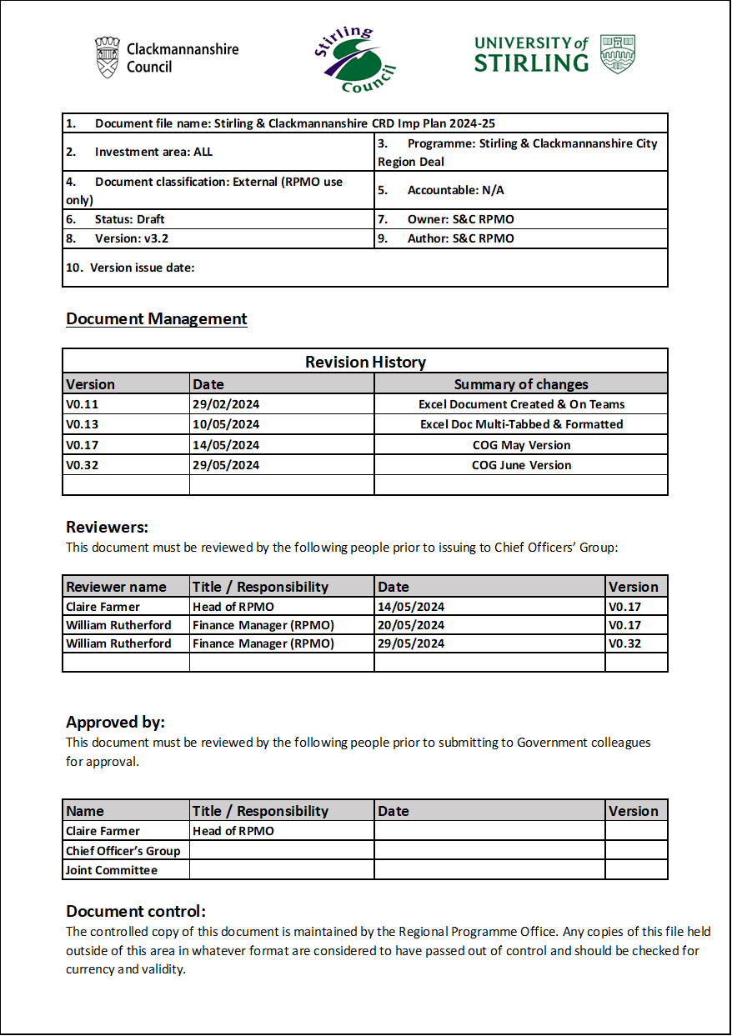

…………………………………………………………………………………………………………………………………

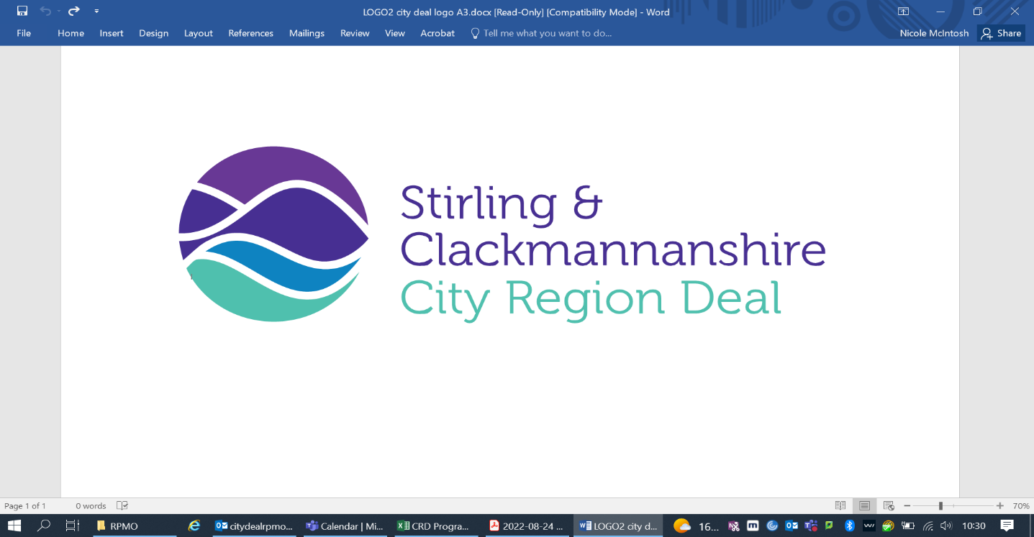

Implementation Plan
2024/25

Index Page

Financial Summaries
1. Core Government Grants Page 5
2. Secured External Funding Page 6
3. Targeted External Funding Page 7
Investment Theme: Transport, Connectivity & Low Carbon
1. Active Travel Routes Page 8
2. Walk, Cycle, Live Stirling Page 10
3. Regional Energy Masterplan Page 13
Investment Theme: Innovation
1. The National Aquaculture Technology and Innovation Hub (NATIH) Page 15
2. Scotland’s International Environment Centre (SIEC) Page 18
3. Alloa Innovation Hub Page 21
4. Proposed Innovation Project Page 23
Investment Theme: Skills & Inclusion
1. Flexible Skills Programme Page 25
2. Inclusion Workers and Investment Fund Page 28
3. Clackmannanshire Lone Parent Programme Page 29
Investment Theme: Infrastructure
1. Ministry of Defence Land at Forthside Page 30
Investment Theme: Culture, Heritage and Tourism
1. Developing Culture, Heritage and Tourism Assets Page 32
2. Japanese Gardens Page 36
Investment Theme: Digital
1. Digital District Phase One – Stirling Digital Hubs Page 39
2. Digital District Phase Two – Regional Digital Hubs Page 41

The financial tables contained within the Implementation Plan show the timing of the claims by source of funds. In many cases, expenditure will be incurred ahead of the Scottish or UK Government funding being available.

The milestone dates relating to the development of business cases are the anticipated dates, but are not set in stone, as the process of business case development is an iterative one. Where there are changes delivery partners will update Scottish and UK Governments through the RPMO, allowing discussions to take place.

Financial Summaries:
1. Core Government Grants. 2. Secured External Funding. 3. Targeted External Funding

Investment Theme: Transport, Connectivity & Low Carbon
Project: 1. Active Travel Routes. 2. Walk, Cycle, Live Stirling. 3. Regional Energy Masterplan

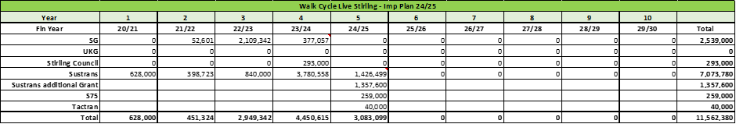

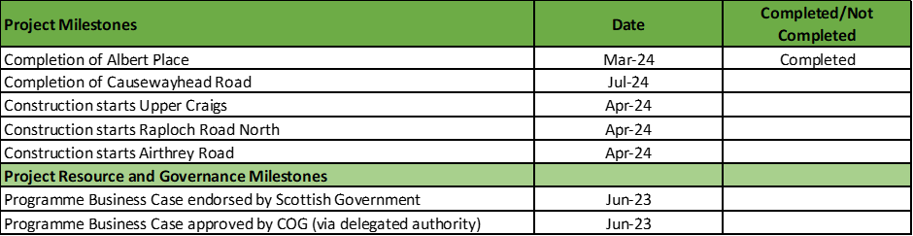

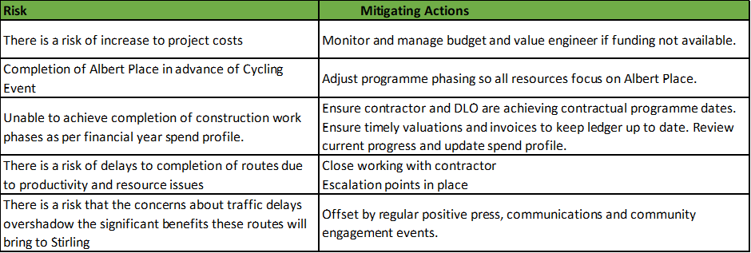

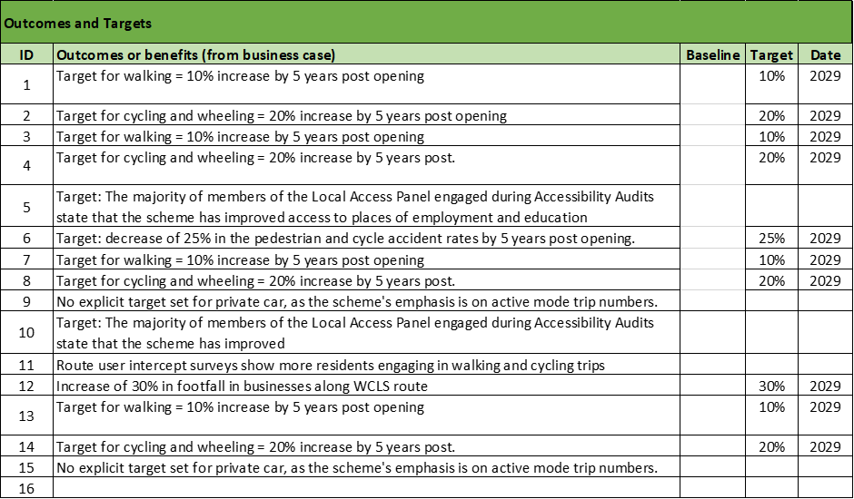

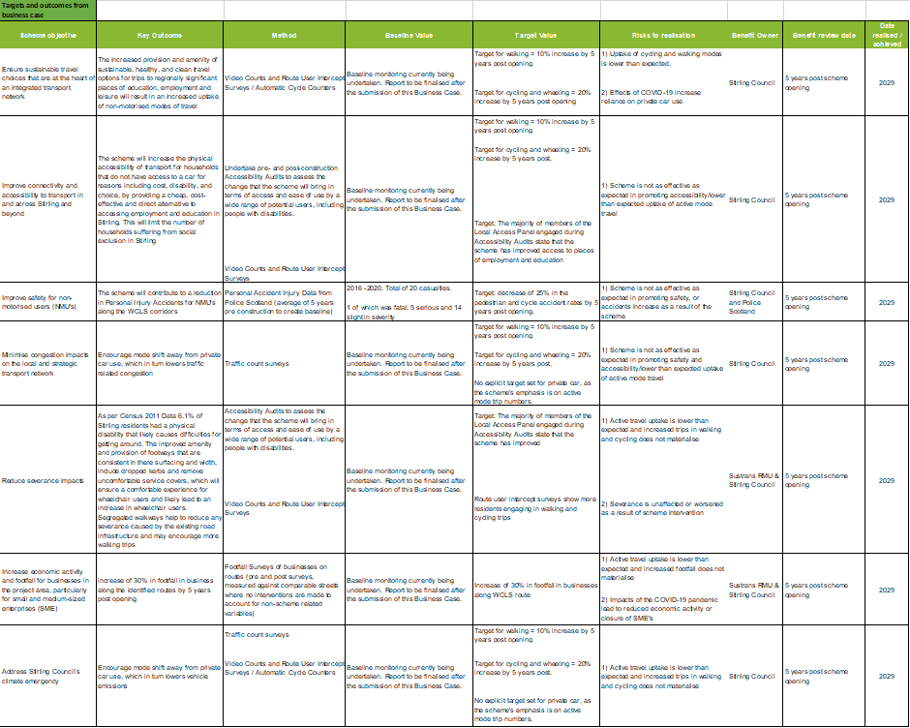

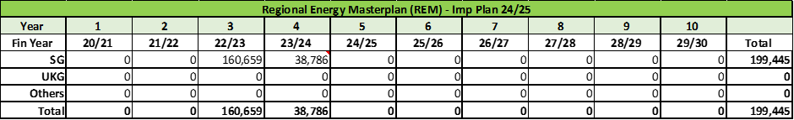

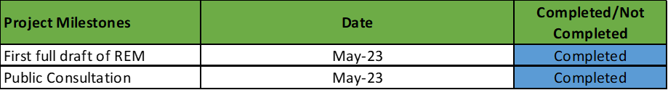

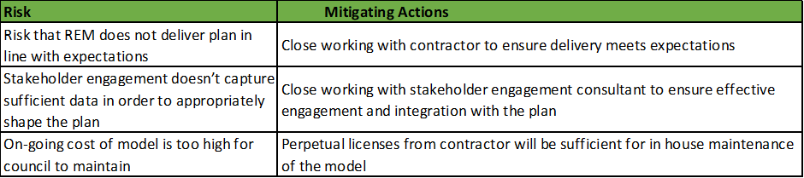

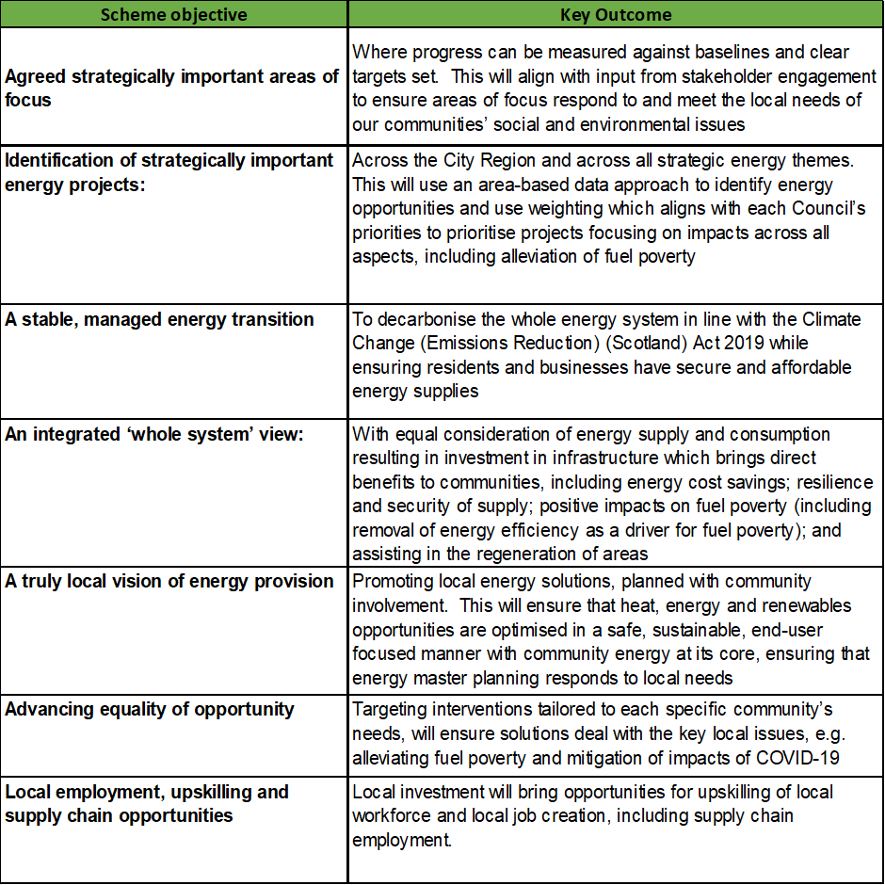

Investment Theme: Innovation
Projects: 1. The National Aquaculture Technology and Innovation Hub. 2. Scotland’s International Environment Centre. 3. Alloa Innovation Hub (AIH). 4. Proposed Innovation Project (NTC)

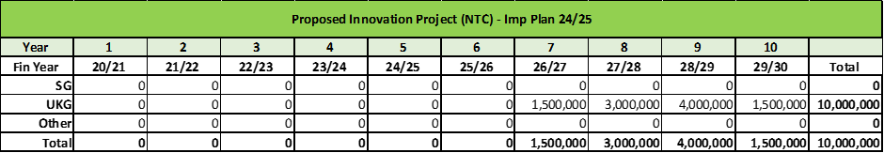

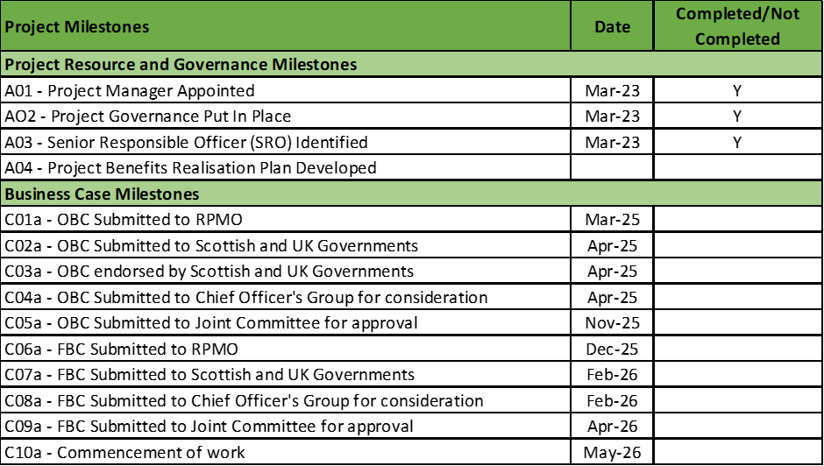

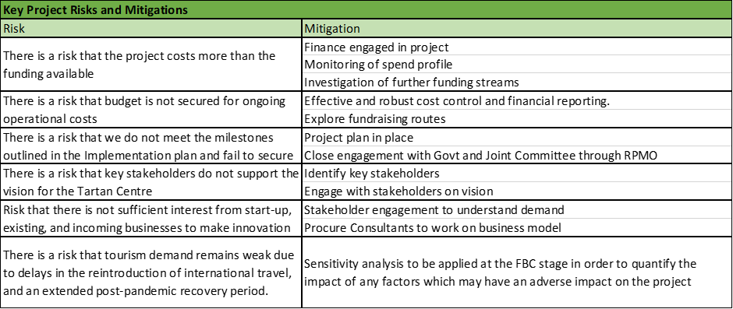

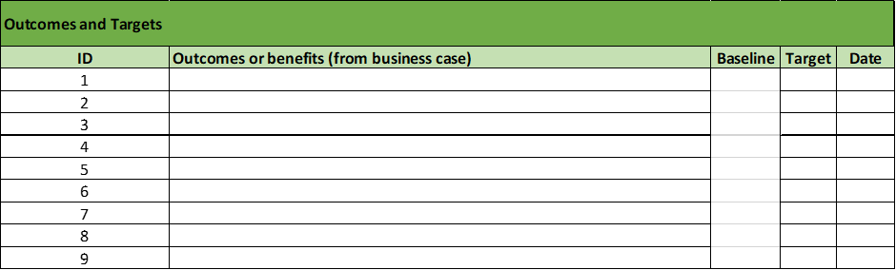

Investment Theme: Skills & Inclusion
Project: 1. Flexible Skills Programme. 2. Inclusion Workers and Investment Fund. 3. Clackmannanshire Lone Parent Programme
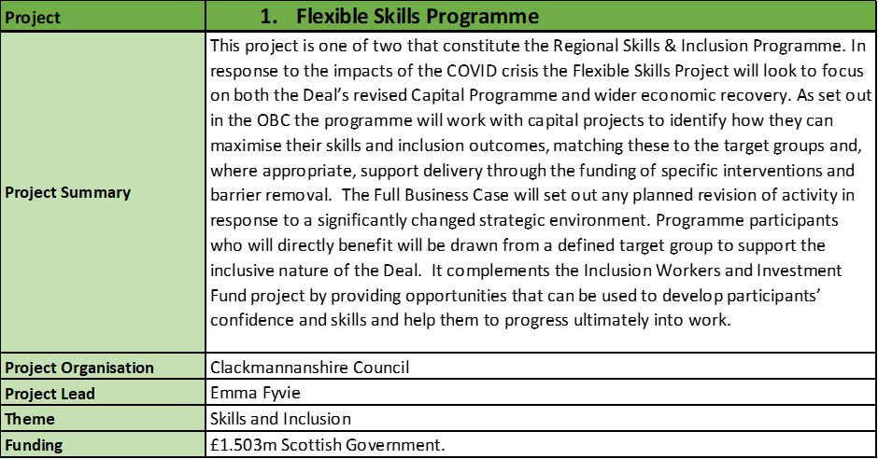

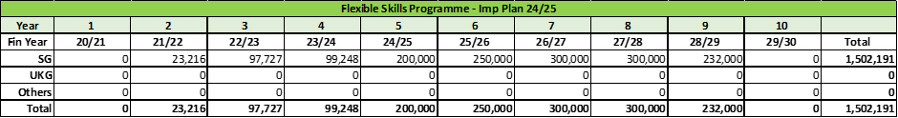

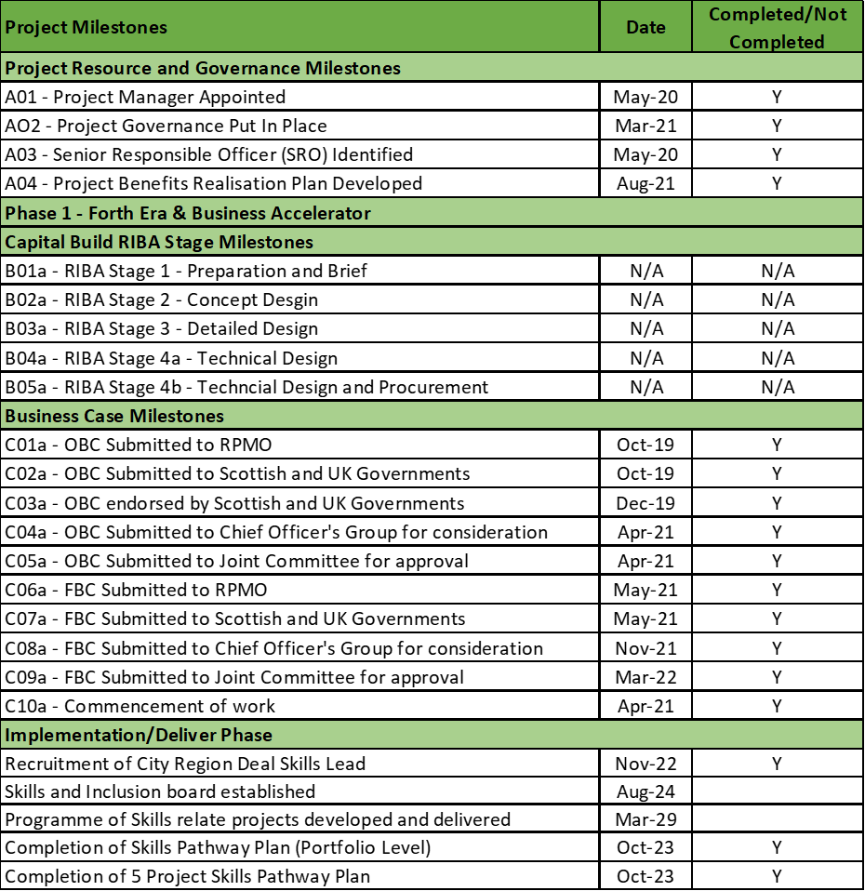

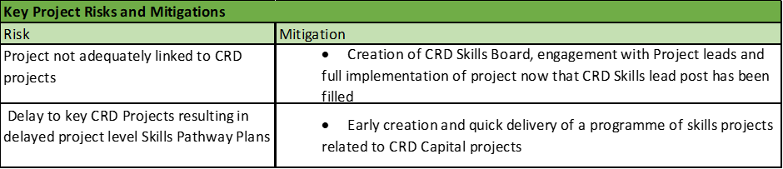

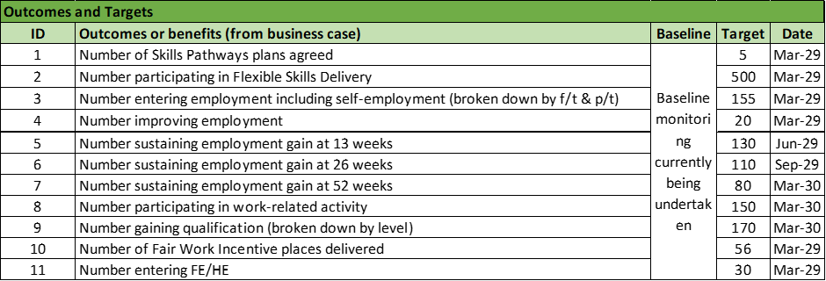

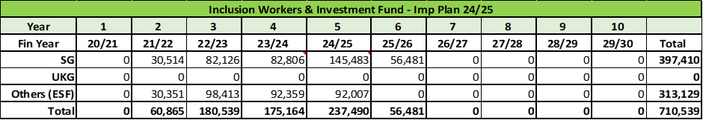

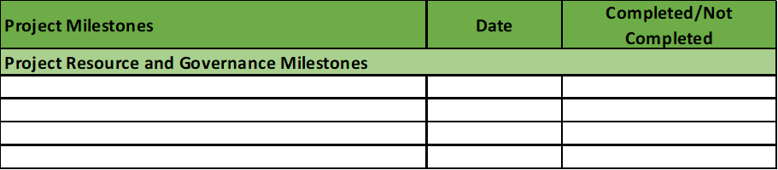

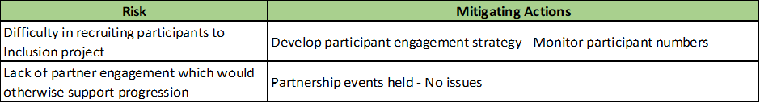

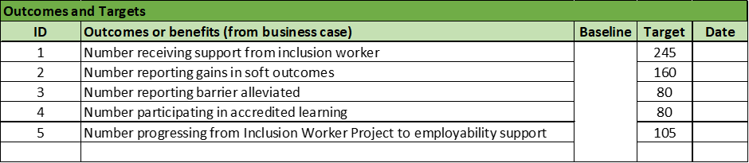

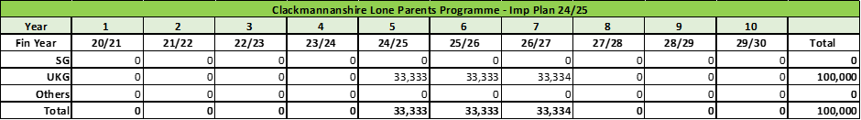

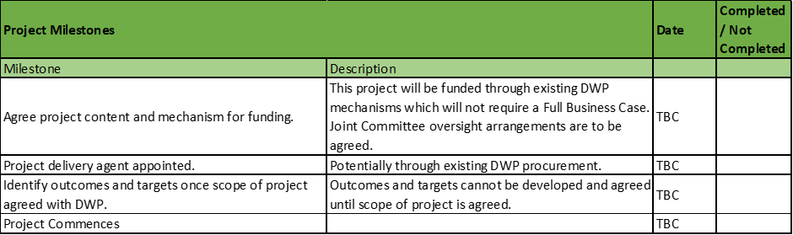

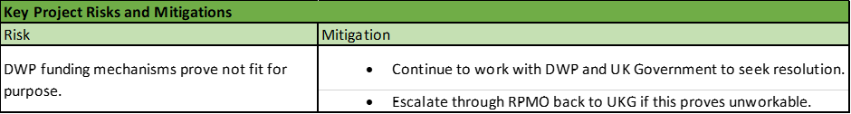

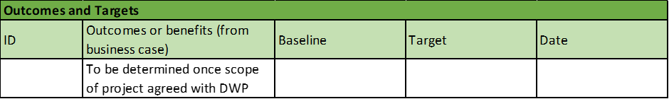

Investment Theme: Infrastructure
Projects: 1. Ministry of Defence Land at Forthside
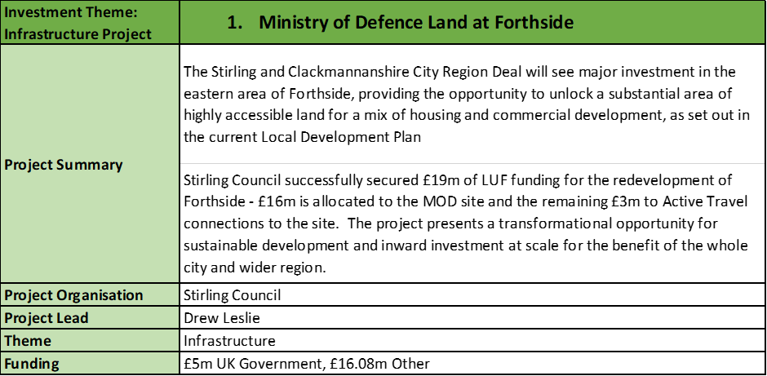

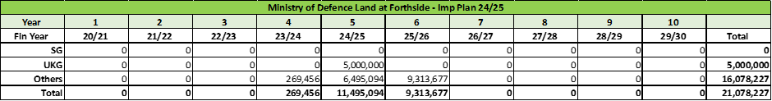

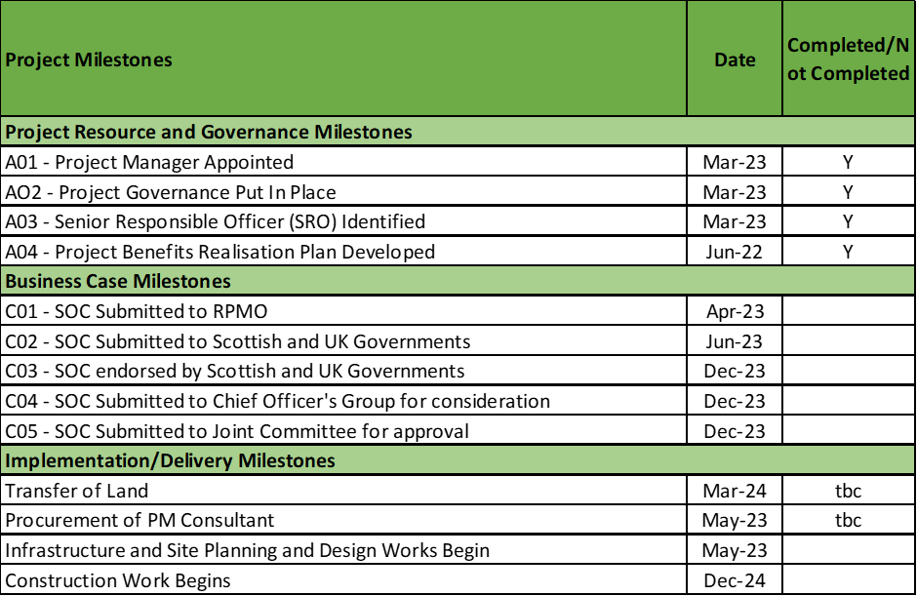
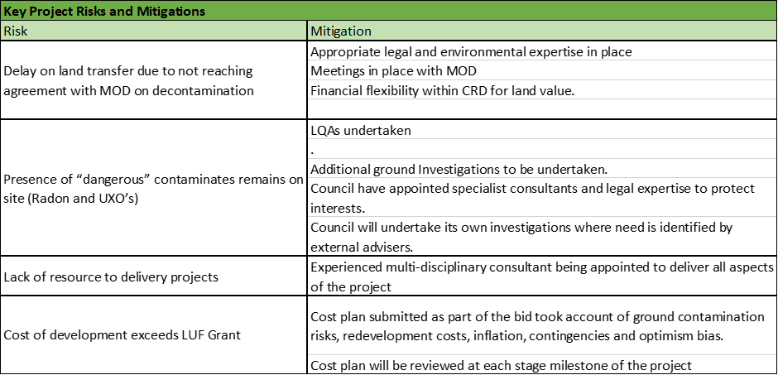

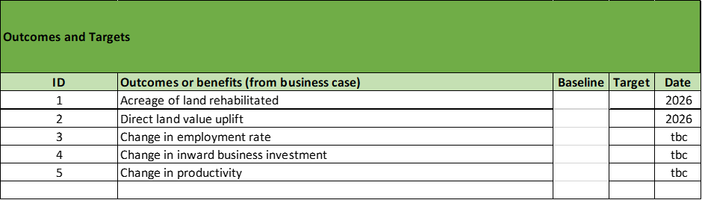

Investment Theme: Culture, Heritage and Tourism
Projects: 1. Developing Culture, Heritage and Tourism Assets. 2. Japanese Gardens

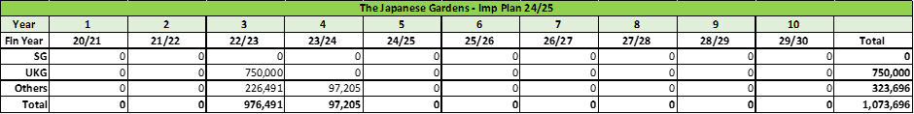

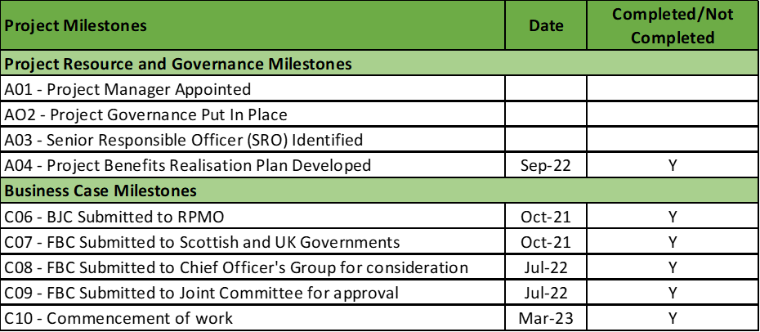

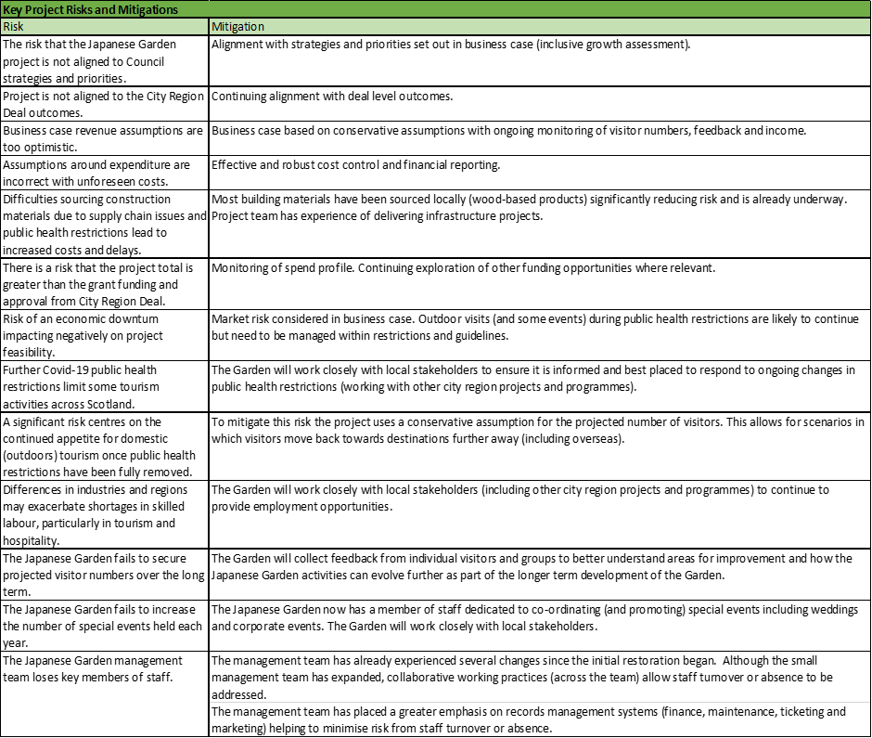

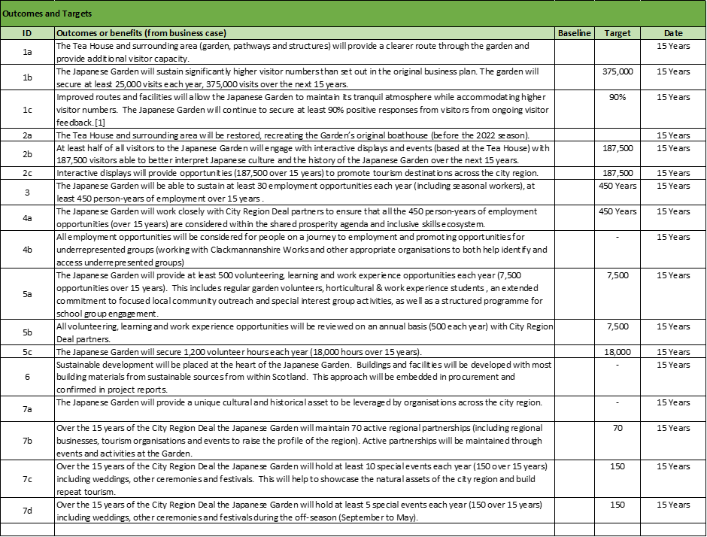

Investment Theme: Digital
Projects: 1. Digital District Phase One – Stirling Digital Hubs. 2. Digital District Phase Two – Regional Digital Hubs.
